Project Report on

"Online Banking System"

Submitted in partial fulfillment of the requirements of . the Value Addition Program on

C Programming

by

|  |  |
| --- | --- |
| Roll No | Student Name |
| B08 | Yash Ghare |
| A41 | Aditya Patil |
| B16 | Rohit kapadnis |
| B17 | Gaurav Yadav |
| A06 | Sujal kalamkar |
| D33 | Aayush Vishwakarma |
| D27 | Smit Gawand |

Supervisor

Dr. Nidhi Singh



First Year Department

Vishwaniketan Institute of Management Entrepreneurship and

Engineering

Technology

Academic Year: 2021 - 2022

Table of Contents

1.Introduction 1

2. Objective 1

3. Why Online Banking System ? 2

4. 2

4.1. 3

4.2 Add Book Screen 3

4.3 Book List Screen 4

4.4 Remove Book Screen 4

4.5 Issue Book Screen 5

4.6 Issued Book List Screen 5

5. Future Scope 7

## Introduction

The online banking system is a project made using the c Programming language. It has been made by various computer language attributes to code the same. With the help of this online banking system the user will able to do banking through online mode. This project is compiled in Code Blocks with the GCC Compiler.

**Online banking**, also known as **internet banking, web banking or home banking**, is an [electronic payment system](https://en.wikipedia.org/wiki/Electronic_payment_system) that enables customers of a [bank](https://en.wikipedia.org/wiki/Bank) or other [financial institution](https://en.wikipedia.org/wiki/Financial_institution) to conduct a range of [financial transactions](https://en.wikipedia.org/wiki/Financial_transaction) through the financial institution's website. The online banking system will typically connect to or be part of the [core banking](https://en.wikipedia.org/wiki/Core_banking) system operated by a bank to provide customers access to banking services in place of traditional [branch banking](https://en.wikipedia.org/wiki/Branch_banking). Online banking significantly reduces the banks' operating cost by reducing reliance on a branch network, and offers greater convenience to customers in time saving in coming to a branch and the convenience of being able to perform banking transactions even when branches are closed. Internet banking provides personal and corporate banking services offering features such as viewing account balances, obtaining statements, checking recent transactions, transferring money between accounts, and making payments.

## **2. Problem Statement and Objective**

**Problem Statement**

The banking industry is witnessing a revolution in products, process, markets and regulations. And It’s a revolution that is not about to stop or even slow down. Since the only option is to adapt and evolve, it is essential that system have the flexibility to quickly adjust the need of today’s financial market.  It’s a tough challenge. Because today’s fast-moving marketplace is also extremely competitive. Moreover, the need to retain existing customers and attract new ones often conflicts with the need to reduce costs and improve the efficiency. But whatever the challenges facing in retail banking operation, Online Banking System - OBS can help to meet and overcome them.

**Objective**

To Automate transactions of bank and providing better and faster service to the customers by using internet

## Why Online Banking System ?

OBS offer flexible, client-server technology based on a scalable system. Its centralized, customer centric design to offers a complete set of integral retail banking modules sharing a user-friendly interface. Online Banking System - OBS is developed for automate the process of day to day transaction of any bank; it has all the features need to operate the banking procedure. The system can be used to create new customer, modify details, deposit and withdraw the amount from his / her account.

### 4. Algorithm

The working of the software can be explained in the following steps:

1. When the user starts the program, he will be presented with the main screen that has six options: a. Add Book

1. Book List
2. Remove Book
3. Issue Book
4. Issued Book List
5. Exit
6. When we press 1, we will get an option to add book in our library. For which we have to enter Book ID, Book Name and author name.
7. To see book list in library, press 2. Here we can see the all books with their ID and author name
8. We also have an option to remove a book from our library. To do so, enter book ID to remove.
9. Issue book to someone is the major part of library. To issue enter 4, and enter the required information of person who has issued.
10. After issue book, to check issued book list, enter 5.
11. To exit, press '0'.

# 4. Graphical User Interface (GUI)

The software developed is a Graphical User Interface based Software and hence has several different screens, widgets and options which the user can interact with. The program consists of six screens:

1. Main Screen
2. Add Book Screen
3. Book List Screen
4. Remove Book Screen
5. Issue Book Screen
6. Issued Book List Screen

### 4.1. Main Screen

The main screen is the first screen that the user sees on starting the program. It has options for Add Book, Book List, Remove Book, Issue Book, Issued Book List and Exit option.

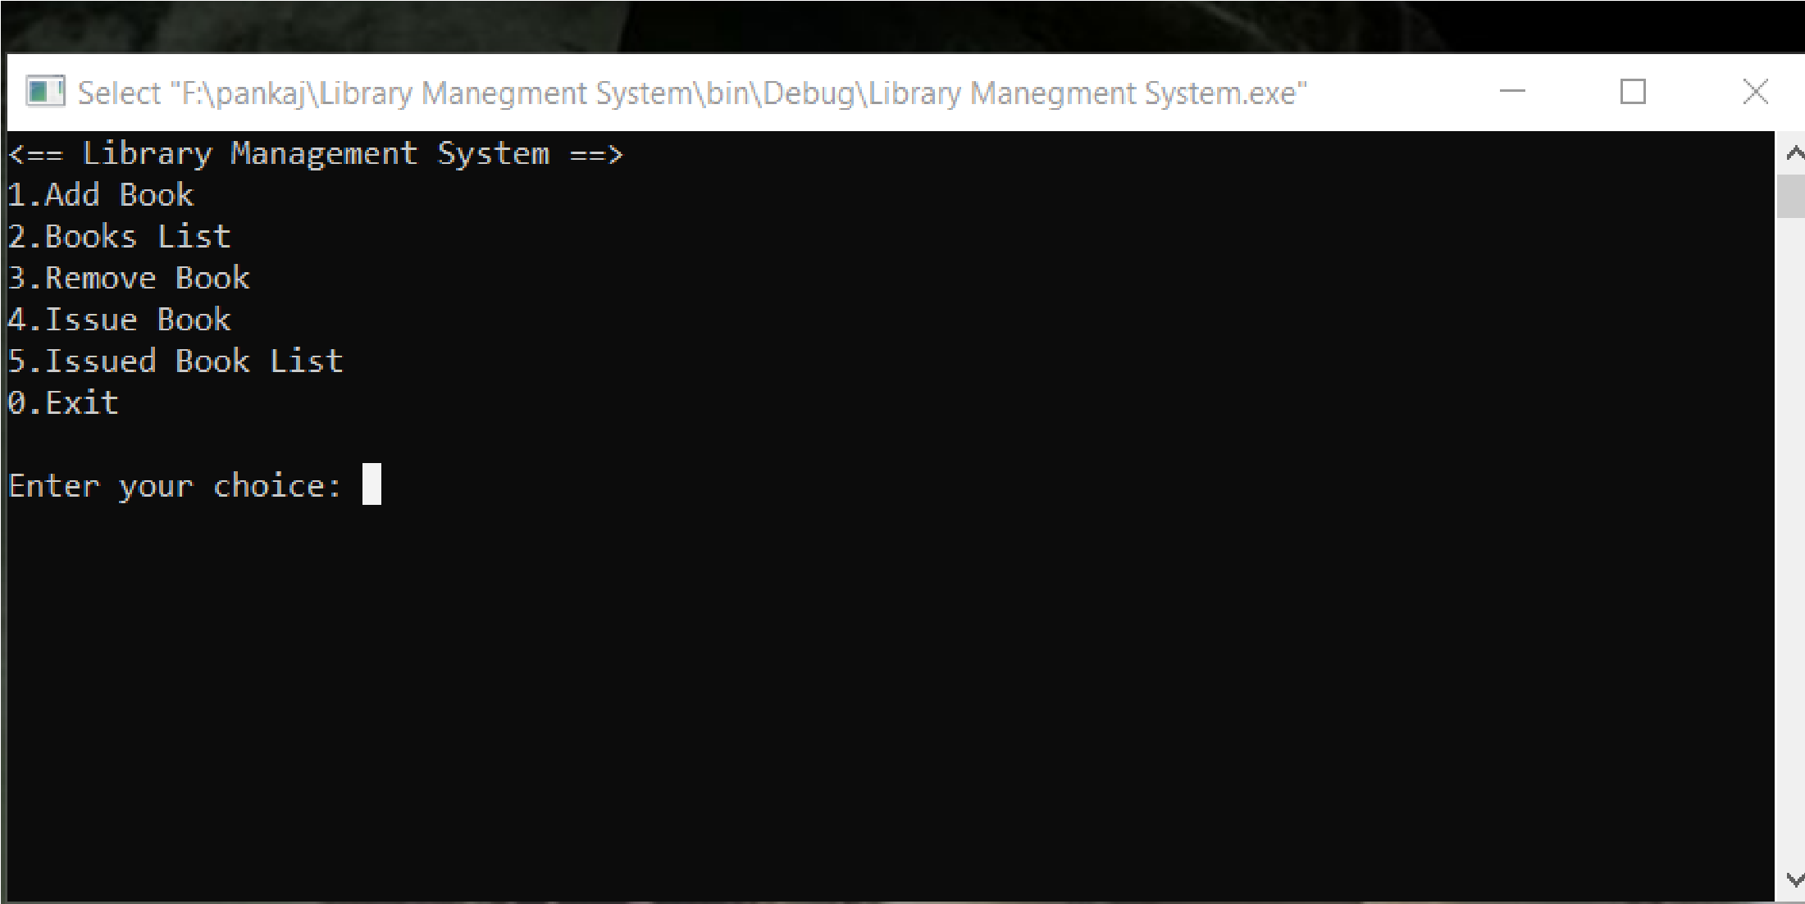

Figure 4.1. Screen capture of Main Screen and New User

Fig 4.1: Main Screen

### 4.2. Add Book Screen

Here to add book we have to Enter BookID, Book name and Author Name. And these data will be saved.

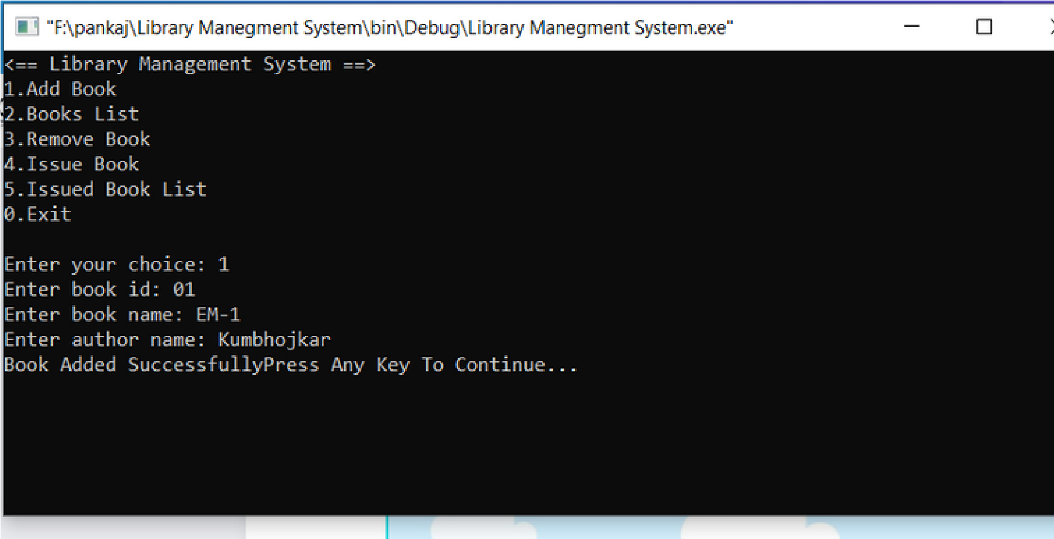

Figure 4.2: Add Book Screen

### 4.3. Book List Screen

This Screen show us the book which we have added in the libarary

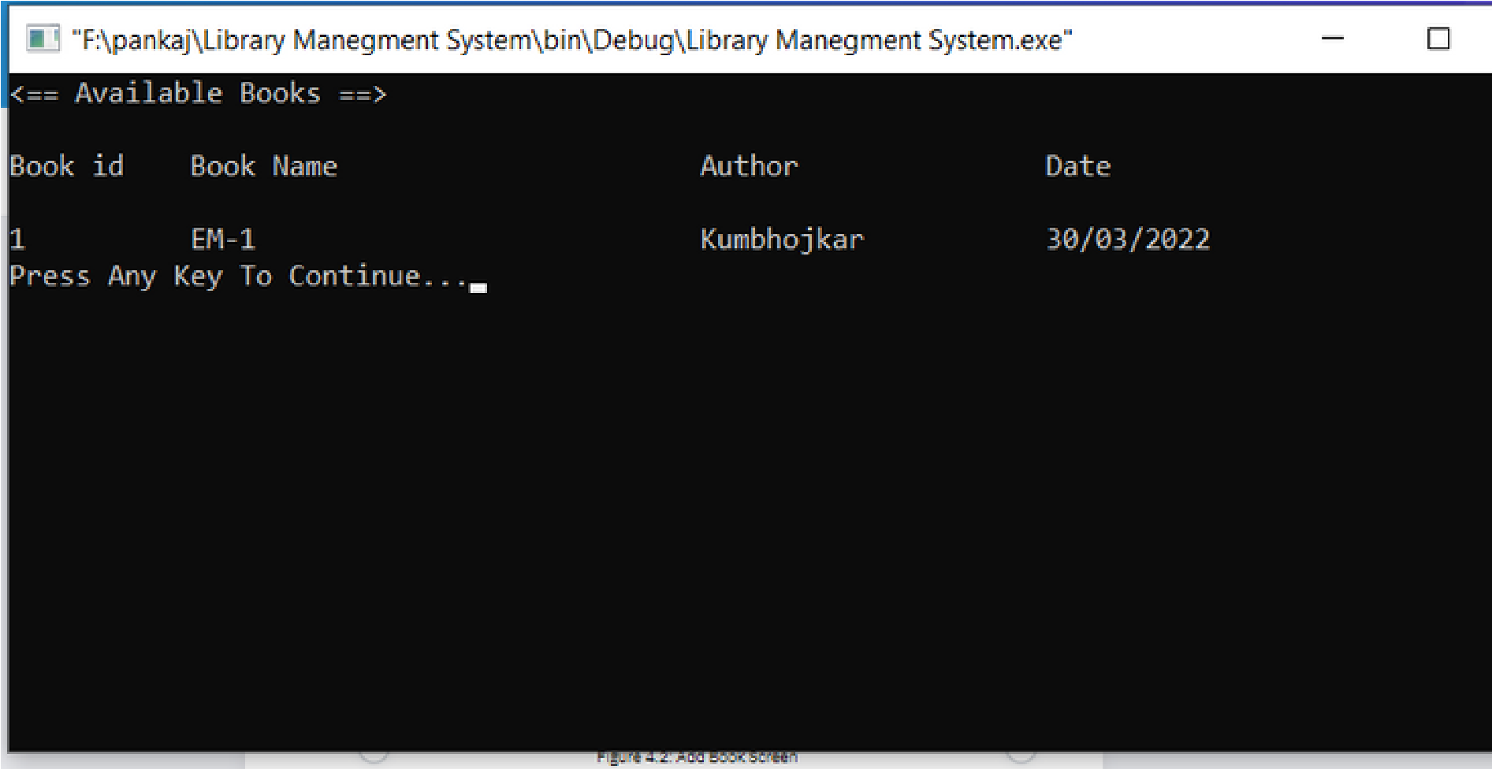

Figure 4.3. Book List Screen

### 4.4. Remove Book Screen

To Remove any book from library, we have to just enter book ID of book which we want to delet.

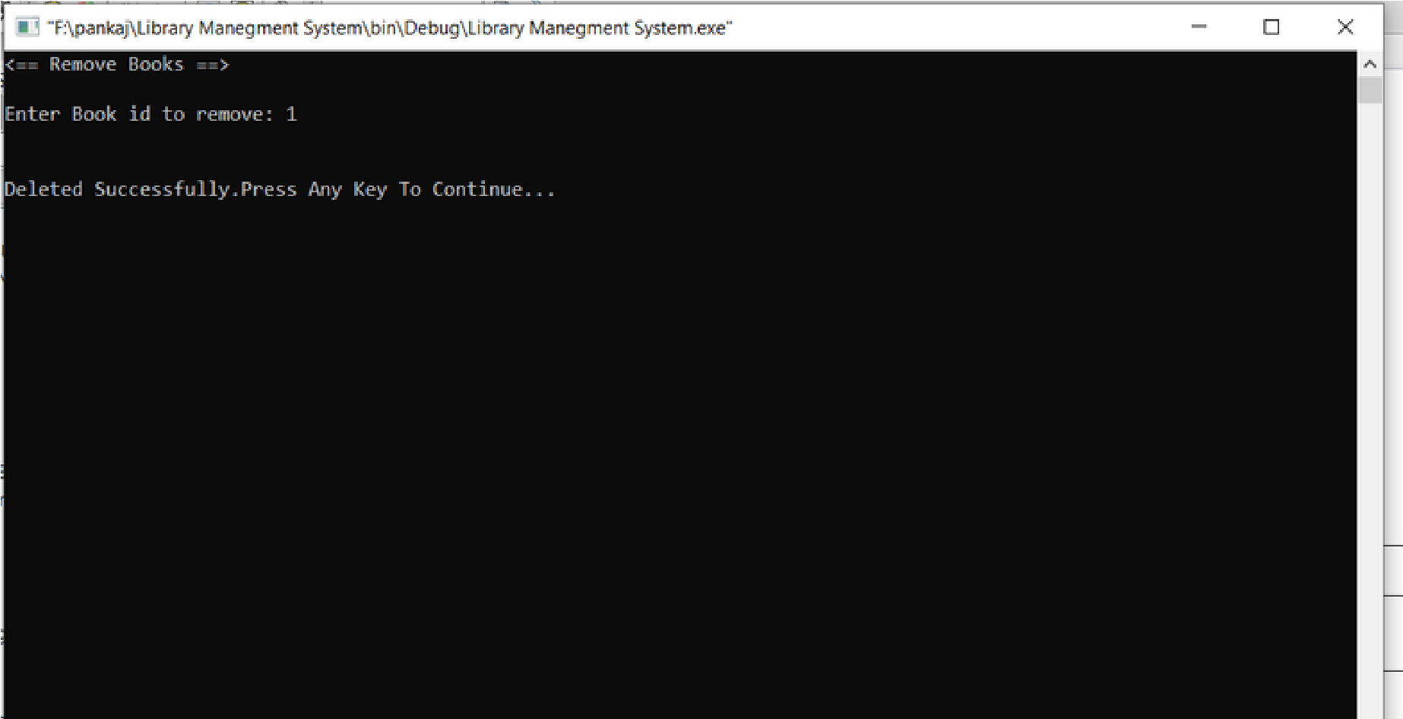

Figure 4.4. Remove Book Screens

### 4.5.Issue Book Screen

To issue book to students, we have to enter Book ID which have to issued, and the other personal details like name, class and roll no of student who has issued the book.

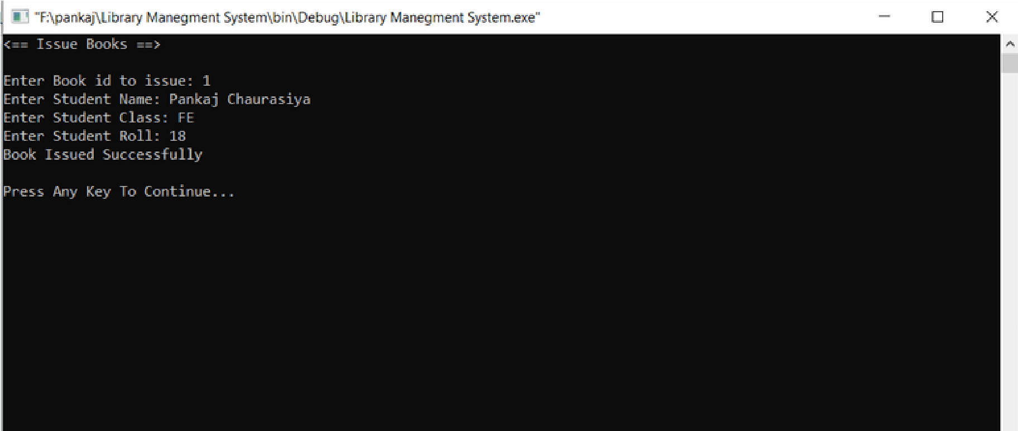

Fig 4.5: Issue Book Screen

### 4.6. Issued Book List Screen

Issued Book List Shows all the books are which are issued to students

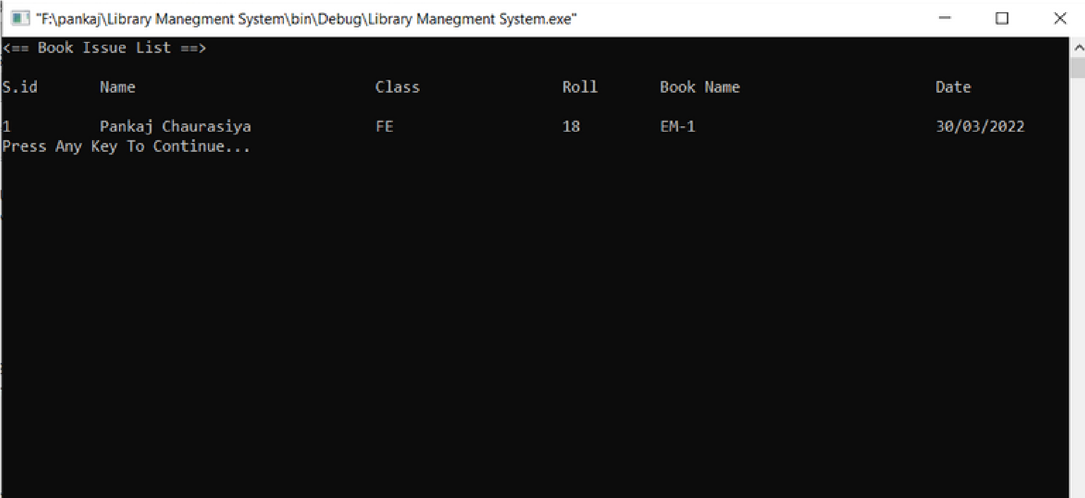

Fig 4.6 : Issued Book List Sceern

# 5. Future Scope

1.Due to the many problems facing with the current system by the college, I made a completely new library management system that can produce automated online system for managing the activities of the library system.

2.It is totally secured system that can be accessed only by the verified user putting the user name and password procedure.

3.To mitigate the issues of conventional and manual method of reservation and distribution of books to readers from library, the online Library Management System has been created. The Library Management System is a web-based online system for assisting both the students/teachers and librarian/staff in borrowing and supervising the books.

4.The system would provide fundamental set of features for adding and/or updating members, adding and/or updating books, getting the list of books, finding out the list of books currently checked out, reserving and borrowing books.